cnc_wrmacro

声明
/* write custom macro variable */
[DllImport("FWLIB32.dll", EntryPoint = "cnc_wrmacro")]
public static extern short cnc_wrmacro(ushort FlibHndl, short a, short b, int c, short d);

描述
写用户宏变量。

参数
（1）FlibHndl 库句柄；[ in ]
（2）number [ in ]
（3）length [ in ]
（4）mcr_val [ in ]
（5）dec_val [ in ]

函数返回值
函数运行正常返回EW_OK。
Return code | Meaning/Error handling
EW_LENGTH  (2) | Data block length error  Size (length) is wrong.
EW_NUMBER  (3) | Data number error  Custom macro variable number (number) is wrong.
EW_DATA  (5) | Data error  Value of custom macro variable (mcr_val, dec_val) is out of available range.
EW_NOOPT  (6) | No option  This function needs the custom macro option.
EW_PROT  (7) | protection error (30i/31i/32i, 0i-D, PMi-A only)  The variable is read-only.

代码
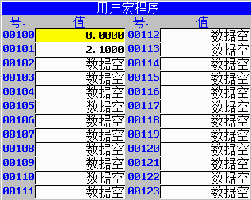
class Program
{
static void Main(string[] args)
{
ushort Flibhndl = 0;

short ret; // 返回值

// 获取库句柄 ( Ethernet )
ret = Focas1.cnc_allclibhndl3("192.168.0.224", 8193, 10, out Flibhndl);
if (ret != Focas1.EW_OK)
{
Console.WriteLine("发生异常，请检查！");
return;
}

#region cnc_wrmacro

short number = 101;
short length = 10;
int mcr_val = 21;
short dec_val = 1;
ret = Focas1.cnc_wrmacro(Flibhndl, number, length, mcr_val, dec_val);
#endregion
}
}

